Please note
Beacon is under continuous development. Screens shown in this document may appear slightly differently in use at any time.
Also, the password you are given when we first set you up with access is a one-time password for use the first time you log in. After that you use the password you created on that first login (see ‘Subsequent logins below.

First Login
The URL to reach Beacon from any browser is https://www.u3abeacon.org.uk/
Your Username and Password will be sent to you by email.
You will see this screen:
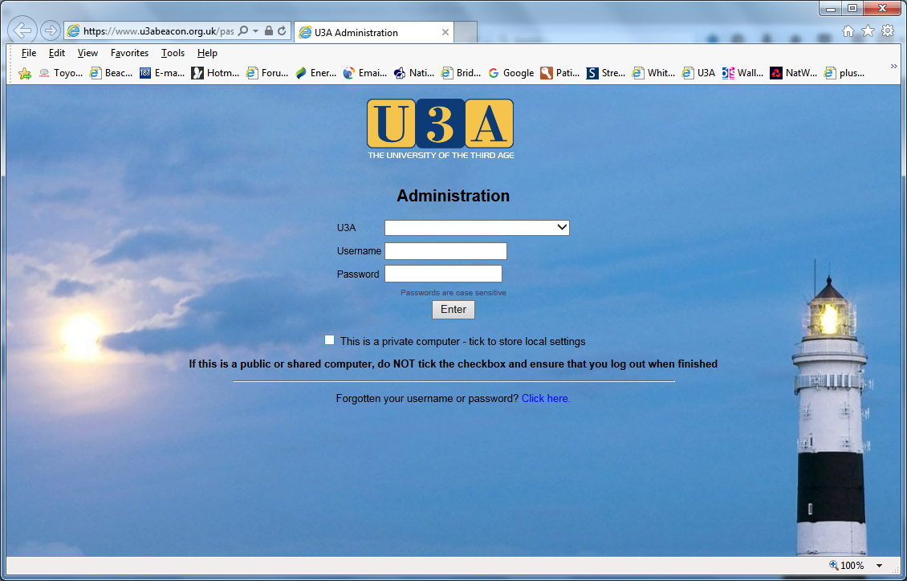
Choose ‘Basingstoke – Old Basing’ from the drop down list of U3A names.
On a private computer tick the ‘This is a private computer’ checkbox – your settings will be remembered for future log-ins.
Remembering that usernames and passwords are both case sensitive, enter your username and initial password (hX_35^Bx) in the relevant fields and click <Enter>
You will be taken to this screen (except, of course, with your own name in it) to set your own password:
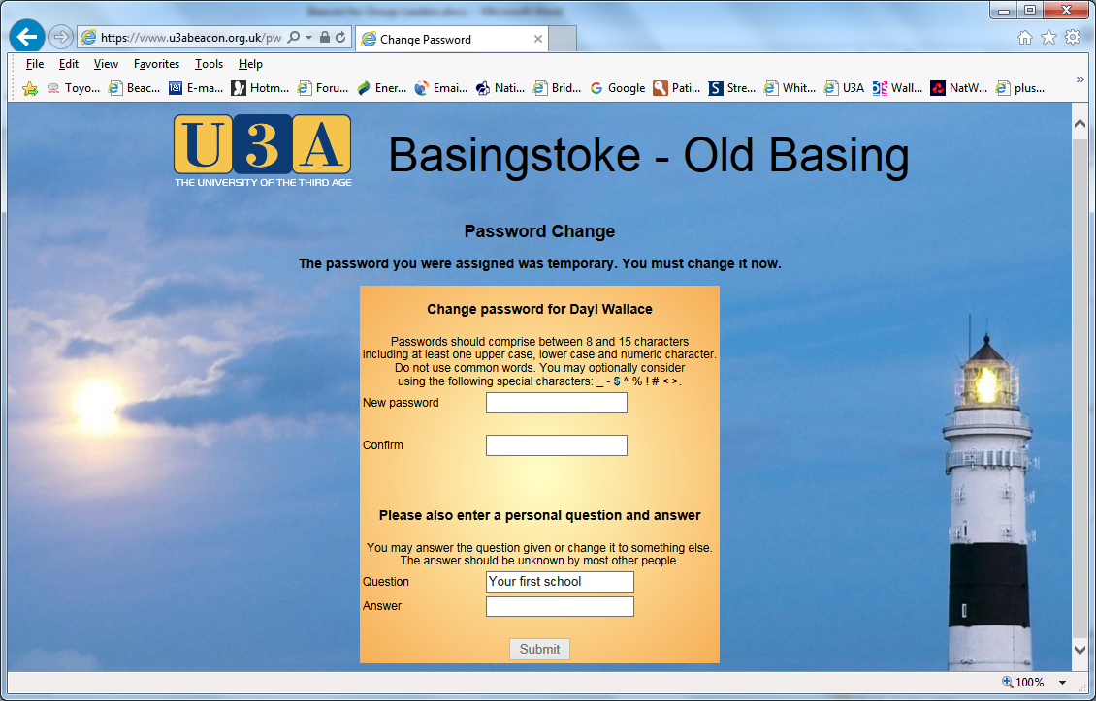
Enter your new password (twice – AND REMEMBER IT), answer the personal question and click <Submit>
You will be taken to this screen:
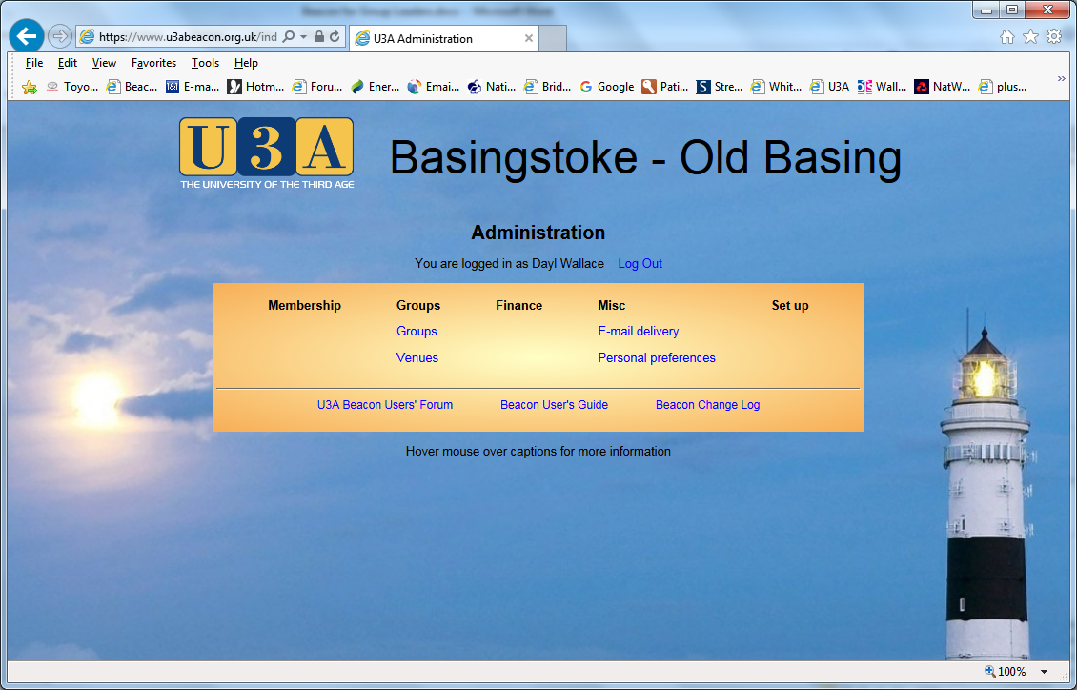
See below for more detail about this screen

Subsequent Logins
After entering the details required (use your personal password) on the login screen (see above for what it looks like), you will be taken to this screen:
I will deal with each entry in turn

Click <Groups> to see a list of groups like this:
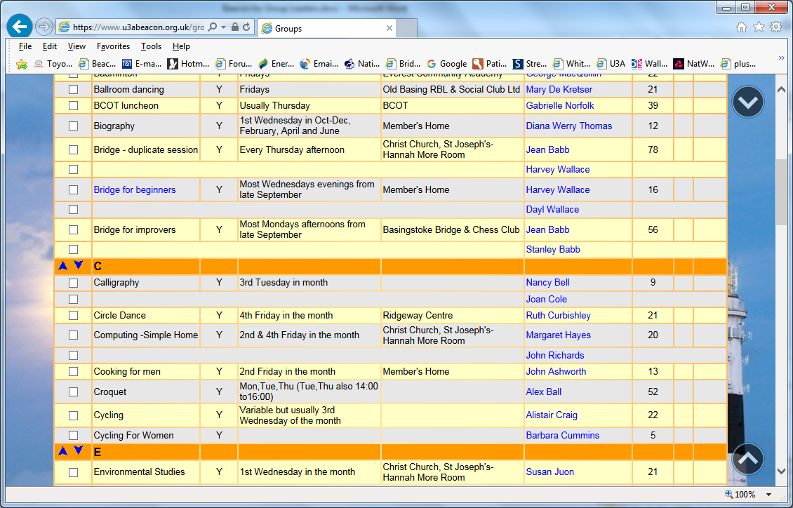
All groups for which you are a Leader will be in Blue (see Bridge for beginners in the example.
Clicking on the name of (one of) your group(s) will bring up a screen like this:
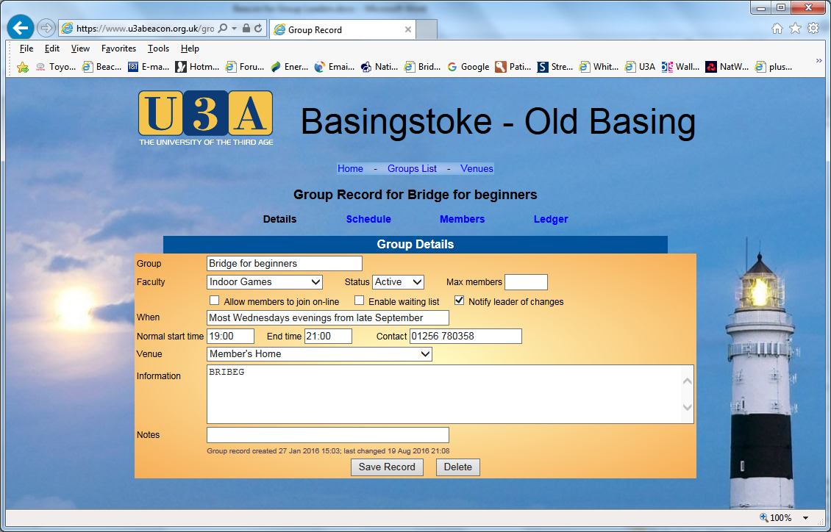
You may edit the fields on this screen and click <Save Record>
You may click <Schedule> to edit your meeting schedule if you wish. The link <Ledger> may not appear and if it does will be inoperable.
Clicking <Members> brings you a list of your registered members like this:
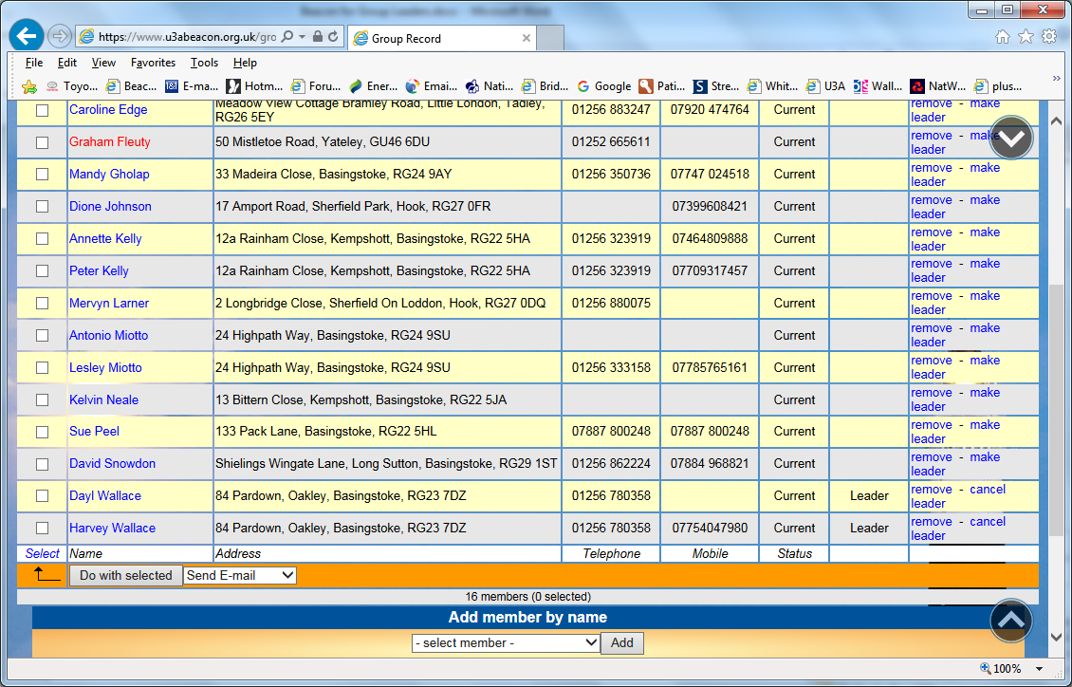
Note that this is for demonstration purposes only, Graham Fleuty and Dayl Wallace are not members of this group and will be removed once this document is produced.
Note that any member showing in red on this screen has not yet paid a fee for the current membership year and should be reminded to do so.

Membership facilities
Note that Graham Fleuty is in red because he has not yet paid his membership fee for this year (at the time of taking the screen shot – apologies to Graham)
Note that it is possible to have two (or more) Leaders.
From this screen you may: remove a member, make a member a leader, cancel a member’s leadership status and add members (by name or number – use the features to the bottom of the screen).
Click a member’s name to see the full membership record for that member (any attempt you make to edit that record will not be saved – you can not amend that record permanently). If you Ctrl/Click instead your browser should open a new tab, leaving this list behind – standard browser functionality.

Email facilities
You may email members (individually or a selection or all) of the group. This email will comply with data protection rules in that each email is sent individually – the recipient can’t see the addresses of the other recipients.
Select individual lines or click <Select> then <Select All> and you can then pick from the drop down list whether to download a list or to email the select members. Click <Do with selected> to action this. You will arrive at this screen:
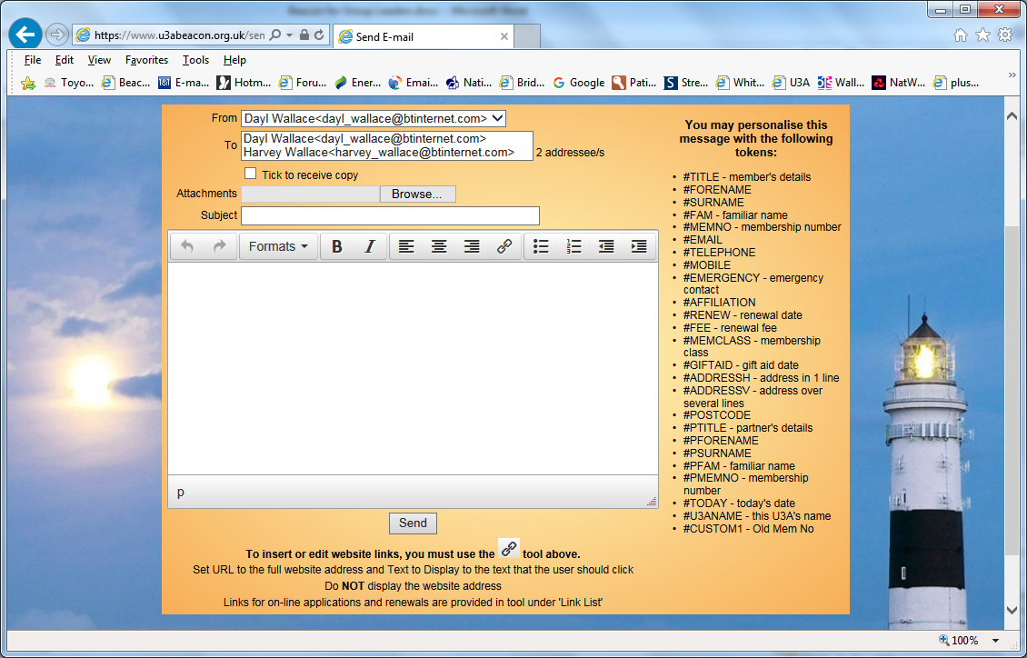
The tokens to the right of the screen can be used in the body of the email to represent the relevant piece of data for the particular member to whom the email is addressed. You may click <Browse> to find and attach a file (or several files) to the email. Compose your email, enter a subject and click <Send>
Back at the main menu:

Miscellaneous features
Clicking <Venues> for a list of venues used by the U3A, from which you can click a venue to see more details.
Clicking <E-mail delivery> only makes sense if you have recently sent an email. Note that some of the data on the delivery of emails can be inaccurate. However, any email failures highlighted should be reported to the Database Administrator (after a phone check with the member regarding spelling – misspelt emails should be reported to the membership secretary for correction).
Clicking <Personal preferences> takes you to a screen which allows some choice in how you view things.

Notes
There is at present no facility for maintaining an attendance register. We have asked for this.
The facility to download group membership data does not currently include the membership number. We have asked for this.
Any failures should be reported to the Database Administrator
If the system won’t let you do something that you think you ought to be able to, ask the Database Administrator to change your privileges (don’t get impatient – this may need committee approval)

